Sunday, April 5 2020
As mentioned in my previous report, this week my orders came in from FibreGlast and getFPV (Fiberglass supplies and a Spektrum Satellite reciever). The system 2000 Epoxy and 2020 hardener recommends a minimum temperature of ~73 degrees F, so I had to wait to work on the “final” (v1.0) prototypes. On Saturday, it was about 68 degrees and the sun was out, so I applied the first two layers of 10 oz Fiberglass on the top of the v1.0 motor mount arms. They took a while to cure, so I didn’t have time to do the bottom surface.
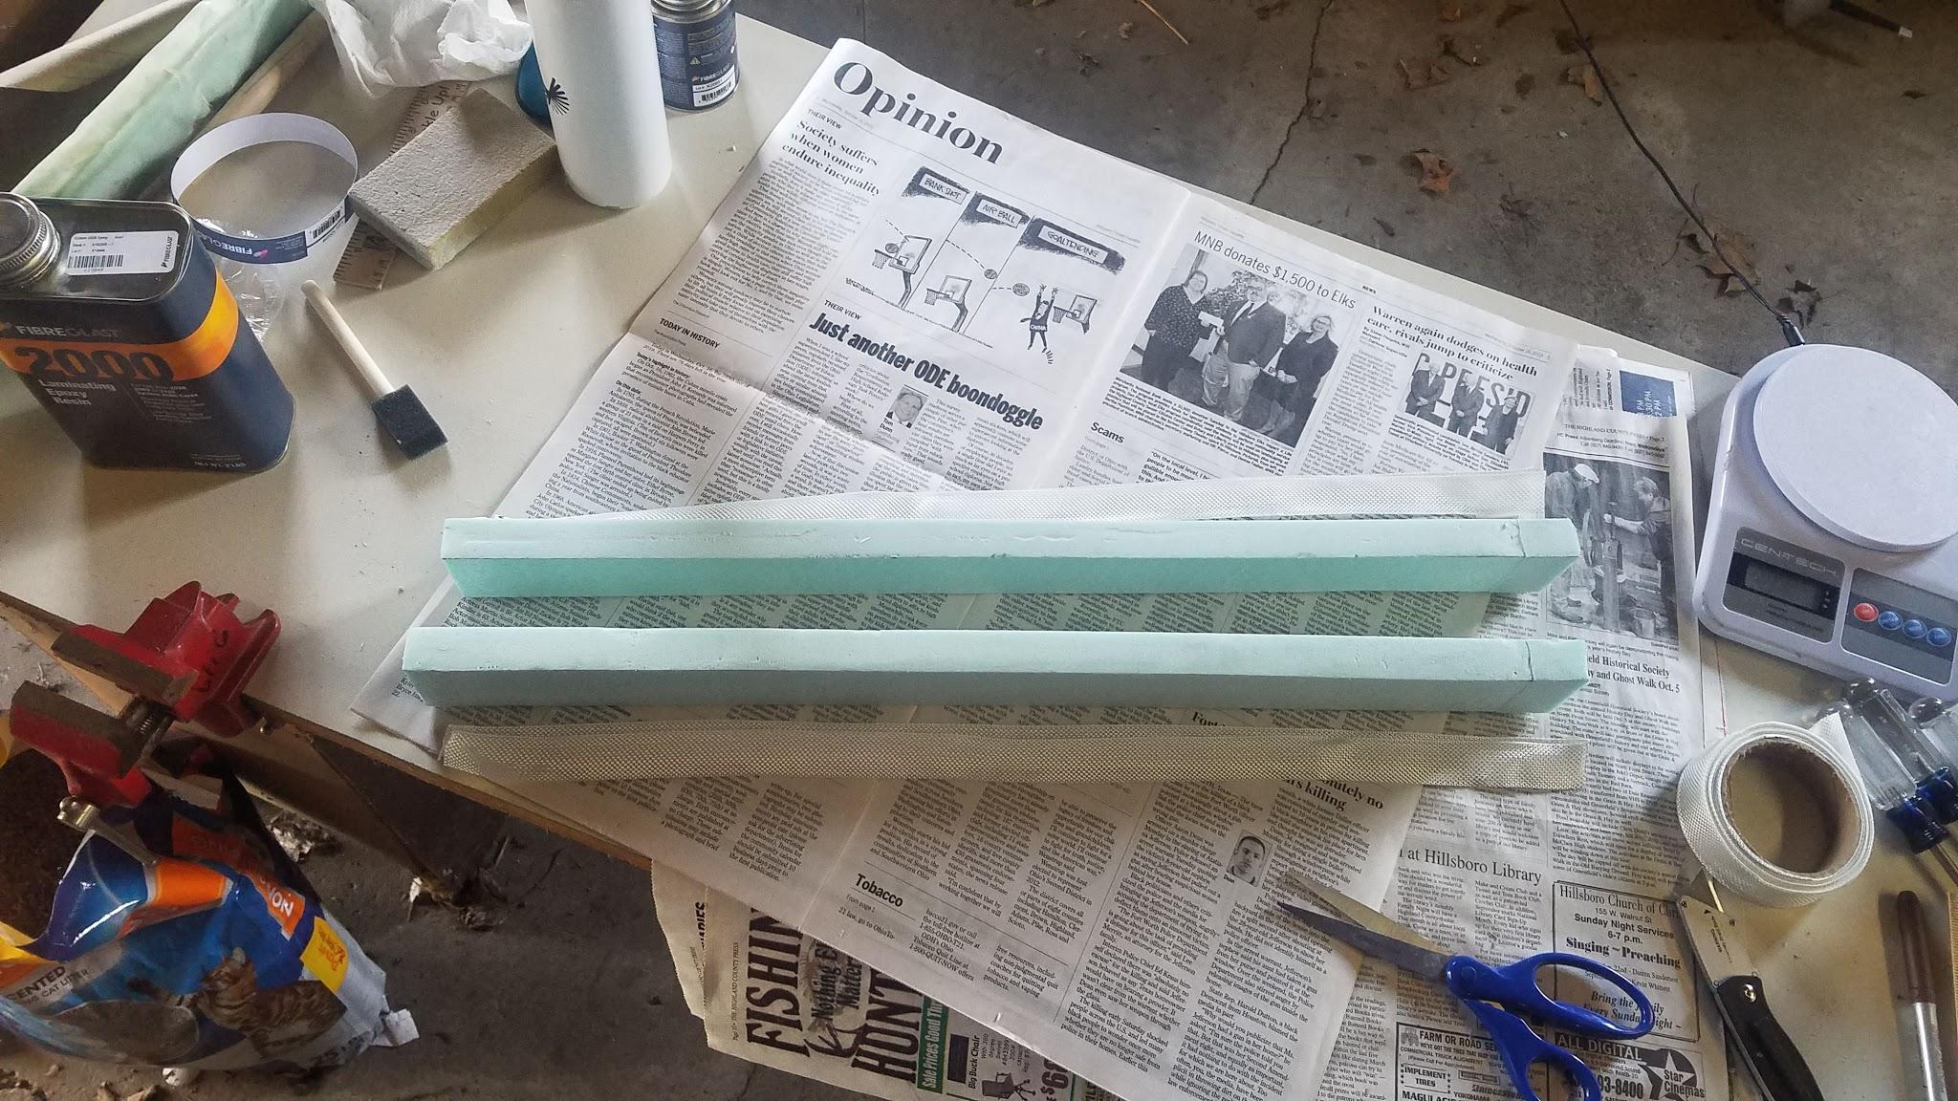

Sunday, it was a little cooler, so I didn’t think it was a good idea to apply more fiberglass.

After this fiberglassing operation, I had significant epoxy remaining in my mixture. Naturally, I looked around and realized I could use this to start fiberglassing the top of my igloo 23 wing. I applied two layers of 5 oz to the right side of the wing. This was very rushed, but the result was okay. It will likely be very aerodynamically sloppy, but that hardly matters for this aircraft.

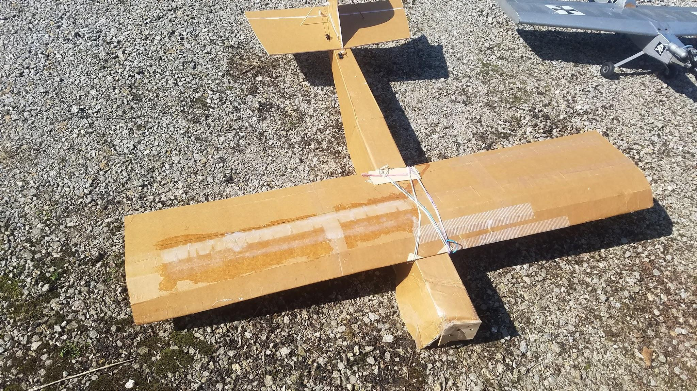

Instead, I worked on the pixhawk. I started out by soldering together the wire included with my new Satellite (remote) receiver and the female end of a solder extension. Using this, I can connect it to the pixhawk’s s-bus connector.

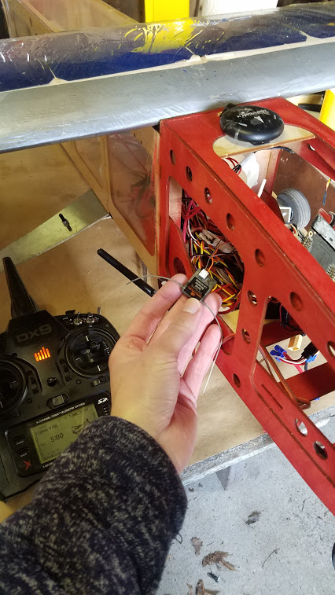

I first connected the new satellite receiver to the pixhawk. Using the transmitter’s (Spektrum DX9) bind function in the “system settings” menu, I attempted to bind to the reciever right after powering up the aircraft. This failed strangely fast. Within seconds, the transmitter was telling me that binding had failed. I tried multiple times and received the same result. Then I tried another way of binding. This time, I powered on the aircraft with the transmitter off. The fpv satellite receiver is designed to automatically try to bind when powered up. With the aircraft powered up and in bind mode, I powered on the transmitter while holding the bind switch. This worked like a charm. Initially flight controls were not powered on, which I assumed was because it was not armed. It would not arm, and I wasn’t entirely sure why. I suspected it probably had to do with the controls not be properly calibrated or it rejecting the arming for various reasons. I knew I needed to see the control inputs and system telemetry to understand what was going on, so I started.

Initially I had some difficulty trying to get the pixhawk to talk to my computer, so I played with the “comm links” settings. I was using USB to connect the pixhawk to the computer. Initially, I checked to make sure the “serial Device on COMx” was assigned to the correct port. In my case, it was COM3. That didn’t fix it, so I played with the baud rate. That didn’t seem to fix it either, so I returned it to default value. Finally, I realized that there was a “connect” button right next to the “edit” button. This worked like a charm, and the dashboard filled up. Step one was to calibrate the inputs from the tx/rx system. Interestingly, the VTOL switch was coincidentally connected to the rotary dial on my transmitter. I don’t know if I would keep that for my flight tests because the dial is difficult to reach, but having the ability to do a partial-transition is a useful capability for testing.

After this, I realized suddenly that my flight controls would not work until they were powered by a BEC (Battery Eliminator Circuit). This is typically provided by an ESC (electronic speed control), but all 4 of my ESCs were removed from the aircraft. So I connected the ESC from my VTOL-mount test setup and immediately gained flight controls capability. Using the VTOL dial on my transmitter, I was able to successfully demonstrate the full hover and cruise control profile for that motor. In cruise mode, I had manual control of the throtte, but in hover mode, I had a sorta blurry control. It was obviously being manipulated by the I-windup in the vehicle’s hover stabilization controller.

I will add that it’s very empowering to see all these controls working. It’s an enticing option to not remove the pixhawk from this aircraft and instead use it for my VTOL testing. The persistent problem with that, however, is transferring torque through the center of the aircraft. It’s also a higher-mass vehicle, which means that the loads would/could be higher. Also, if I get past hover testing, I could not use this aircraft for transition testing until the quarantine ends and I can access the outer wing panels (which are still at the University).

Assuming I continue to press on with Igloo VTOL Test Aircraft,
To-do:

Week of: April 6-10
- Sand/cut the existing fiberglass on my motor mount arms
- Finish fiberglassing my motor mount arms (left is done, right is waiting on warmer weather).
- Finish fiberglassing top of my igloo wing panel
- Figure out (specifically) how I can integrate my final motor mount arms to the wing.
- Check for prop, ground, fuselage clearance.
- Rebuild the nose of the Igloo aircraft fuselage, make sure battery mounts correctly.
- Reinforce the locations for mounting the arms.
- Update CAD model to include flight controller placement

Week of: April 13-17
- Investigate the necessity of having landing gear on the igloo aircraft
- If necessary, re-mount the landing gear on Igloo aircraft.
- Test-install the left motor-arm
- Make the power wiring harness
- Finish fiberglassing the right motor-arm
- Finish building the right motor-arm
- Put together the signal wiring harness. Glue when ready.
- Make the control wiring harness
- Finish the full construction and integration of VTOL motors, including wiring.
- Integrate the pixhawk on the Igloo airframe.
- Finish software setup and prepare for hover testing.

April 6, 2020
I’m having some difficulty coming up with a convincing integration of these motors and the igloo wing. I am still somewhat interested in the possibility of just putting my new arms on the old airframe. However, probably the biggest limitation of deciding to do that would be that I do not have access to the outer wing panels, and I will not until at least when the quarantine ends in a month or two. Assuming I can come up with a decent way of mounting the motors to the igloo wing, I think the igloo VTOL Test prototype could be ready for flight tests around the end of next week.

Building a new center-wing section for muse isn’t really an option because I lack most of the materials. I think it could be feasible to swap out the balsa outer-panels for ply ones that I could make based on the plans. This would transfer the load to the wing’s structure more effectively than the half-baked solution in place right now.

After working on a basic CAD model of the igloo test aircraft, I think I understand how the aft motors can be mounted, the motor arms can be mounted to the wing, and there can still be clearance for aileron movement.

The motor arms will be mounted to the wings via rubber bands, just like the fuselage. I will make holes in the wing just forward of the ailerons, so they’re not affected. The arms will be suspended about .7” below the bottom surface of the wing to ensure that they are not interfering in the aileron range of motion. I will have to print (or otherwise make) a standoff for this purpose.

The aft motors will be mounted just above the motor arms. The image below shows an outdated (kinda) model for the arms. Initially I planned to use long M3 screws (~80 mm) to reach up and support the motors, but due to the high likelihood of instability, I have switched to a new scheme. The arms for this vehicle will not be tapered like that, and instead will be a constant rectangle about 2.25-2.5” tall. This is consistent with my current v1.0 prototypes (see above). Once I am certain about this height, I will probably 3d-print a bracket to fit neatly around it and secure the motor. Then I can use a compression screw or two to secure that bracket to the arm.
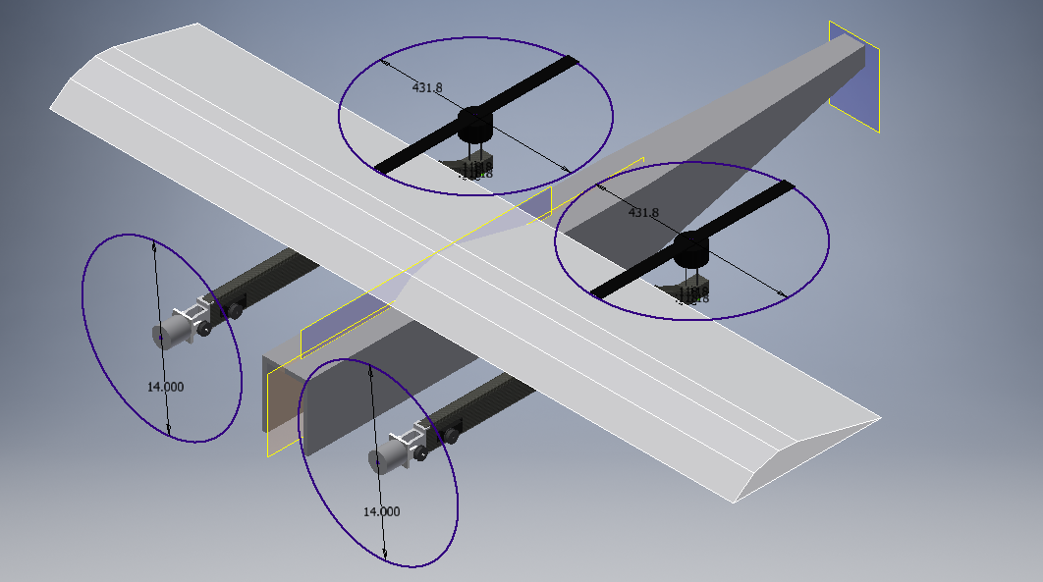

April 8th, 2020

So I have made considerable progress on the fiberglass arms. With only the two layers of 10 oz fiberglass applied on the top and bottom, each of the two parts came in at 80g

As of today, I have applied the fiberglass for both shear webs on one component and one on the second. I am waiting for both to cure before applying the last shear web on the second arm. During the initial shear-web curing process, I had trouble getting adhesion between the glass I was applying and the top and bottom surfaces of the arm. My on-the-spot solution to this problem was to wrap it in plastic wrap and apply pressure with a yard stick weighed with other objects. This would ensure the form of the part was correct. I spent so much time on this that I did not even begin to work on the second arm. That is why they have different numbers of layers applied so far. I was not sure whether I would be able to remove the plastic wrap, so I attempted to remove it before the epoxy was entirely cured. This turned out to be a mistake. The quality of my shape was significantly lessened, so I had to go back and do significant sanding and trimming with tools. After applying this one shear web, the part weighed about 110g. At this point, the part easily supported a 10 lb weight suspended in the center, but this is ~½ of the maximum weight it should hopefully see under operation (not including vibration, safety factor, or other happenstances).

In the second shear-web curing operation, I applied glass to both arms because I knew what to expect. I am concerned about finishing the last curing operation for the second arm because it is forecasted to be rather cold the rest of the week. In theory, I shouldn’t cure epoxy in such conditions. On the bright side, I should be able to extensive integration testing of the first arm.

I am currently working on trade studies for the configuration of the final “production” aircraft.

April 9, 2020
Today I unpacked the fiberglass motor arms (from the wrapping used for fiberglassing yesterday. I did a simple load test with each of them, demonstrating the capability of each arm to support 20lbs in the center while being supported at the edges. Both arms passed, despite the fact that arm #2 does not have its second shear web yet.

After doing this, I also installed the motor mount and servo for Arm #1. I need to make some further adjustments to fit and installation, but it does work already. Unfortunately, I will probably not have internal wiring on this iteration. It’s just not worth it, and I did not plan for that.

I also rebuilt the CAD models for the motor arms so they now match the v1.0 arm production design.That is, they are now correctly modeled as constant-height. I came up with a simple design for mounting the aft motors to the arms and another for mounting arms to wings.

After this, I went through and improved the overall fidelity of the model. I put in mass numbers for the motors, escs, fuse, wing, and pivot servos. I put in the model for the 5S lipo battery and adjusted the relative positioning of the wing with respect to the fuselage.

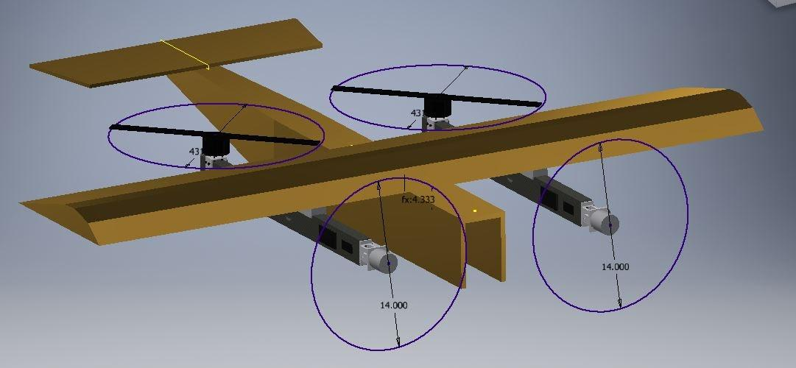

April 10, 2020

So I started printing the aft motor mounts and wing-arm mounting spacers. I figured out that with separate processes running in parallel, I should be able to print them simultaneously with different infill levels. The spacer has a 15% infill, while the aft motor mounts are 100%.

April 11, 2020

I made a number of improvements. I did a simple fit check of the aft motor mount, and it seemed to work. While I was at it, I spun up that motor for fun. I also worked further on the aircraft’s CAD model. I added the pixhawk and gps in front of the aircraft’s wing, and I placed the receiver and power distribution board just underneath (inside the fuselage). While I was at it, I made a new part in the assembly called “wiring diagram” that served to help me understand where to route wires. It looks like they’ll mostly be going under the wing directly into the fuelage.

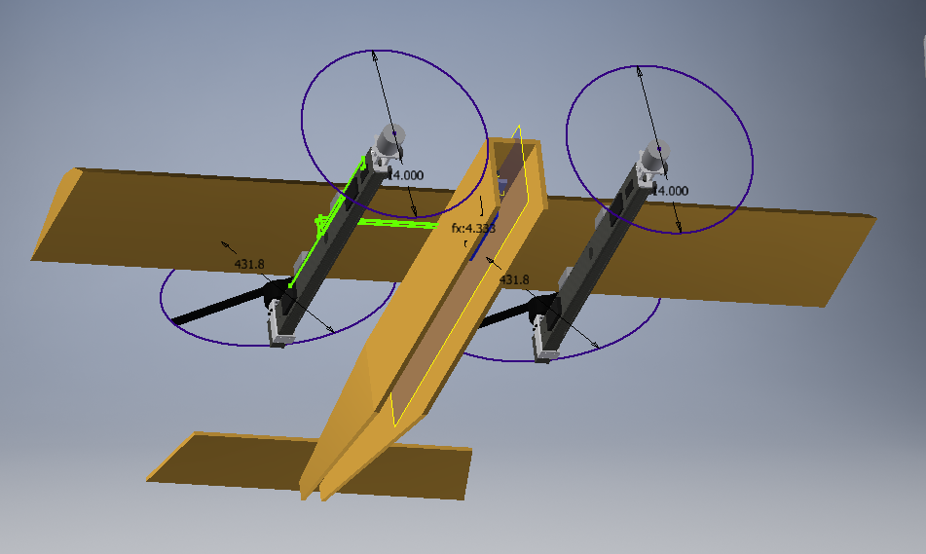

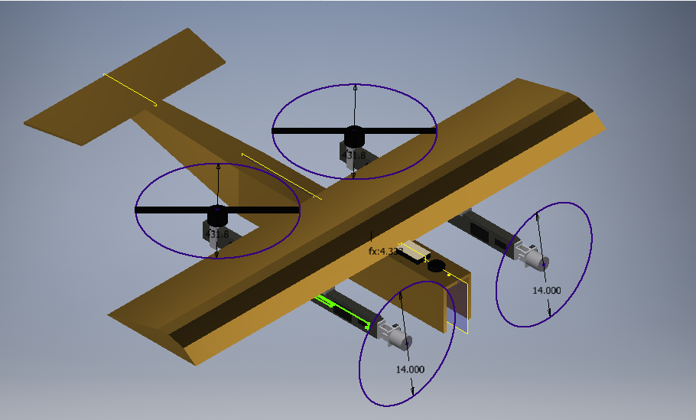

April 12, 2020 (Easter Sunday)

Today I did a super-simple load test of the 1st version of the aft motor mounts. I suspended a 20 lb weight beneath the aft motor (hanging from the prop), and it held just fine. Not accounting for motor torque, this should be a conservative test. I have yet to do a load test of the forward motor mount while it is connected to the motor-mount-arm.

I also took the time to calculate the type and number of XT60 and XT90 connectors I would need for the aircraft’s power wiring harness. Also included was the amount of 14 guage wire. My only major concern is that I’ll draw too much current through this wire. It’s very possible, as I expect to draw out of one 5S battery (as of right now). If I had to, I could try to switch to a harness of multiple 6S batteries or 3S batteries wired in series and parallel…. I’ve got options. But either way, it’s liable to be annoying. According to the internet, 14 guage wire is “rated” for 18 Amps, but it’s not clear to me where that comes from. If it’s based on voltage drop, that’s interesting because that rating is for wires “0-50 feet.” I definitely don’t have 50 ft of wire. Not even close. Probably the biggest things I care about are:
- Not overheating and burning through my shrink wrap. This is possible.
- Not overheating and melting my solder. This would probably happen after 1, but I’m not sure.
- Not overheating to the point of causing some other damage to the aircraft’s internals, including airframe and electronics. I suspect 1 or 2 would happen before this, but I could be wrong.
- Not having an insanely large voltage drop over the few inches in which all this current would be going through one set of wires. This is inherently unlikely due to the short length, and before this became a problem, 14 guage wire in this system would be way too small everywhere. So if this is a problem, I’ll have much bigger issues instead.
Probably the name of the game here is to be careful, do some on-the-ground motor runup tests and then check the wire temperature, and don’t hover for a long time if you think there could be an issue.

Last question I have is whether my super cheap Hobbyking 5000 mah 5S lipo can deliver enough current to hover this (small) beast.

I have a concern about the rubber-band motor arm mounting concept. The idea is to use rubber bands to mount the motor-arms to the wing and then (again) use rubber bands to connect the wing to the fuse. The problem is whether the rubber bands will be strong enough to transfer that load through the wings. Hover isn’t a huge issue, but cruise could be. I guess I could do some static load testing and then a run-up test before flight, but it’s still a big programmatic risk. Also, I currently am planning to fly this with my 5S lipo. This could help reduce the max thrust, but I’ll still probably want to set a throttle-limiter in the flight controller.
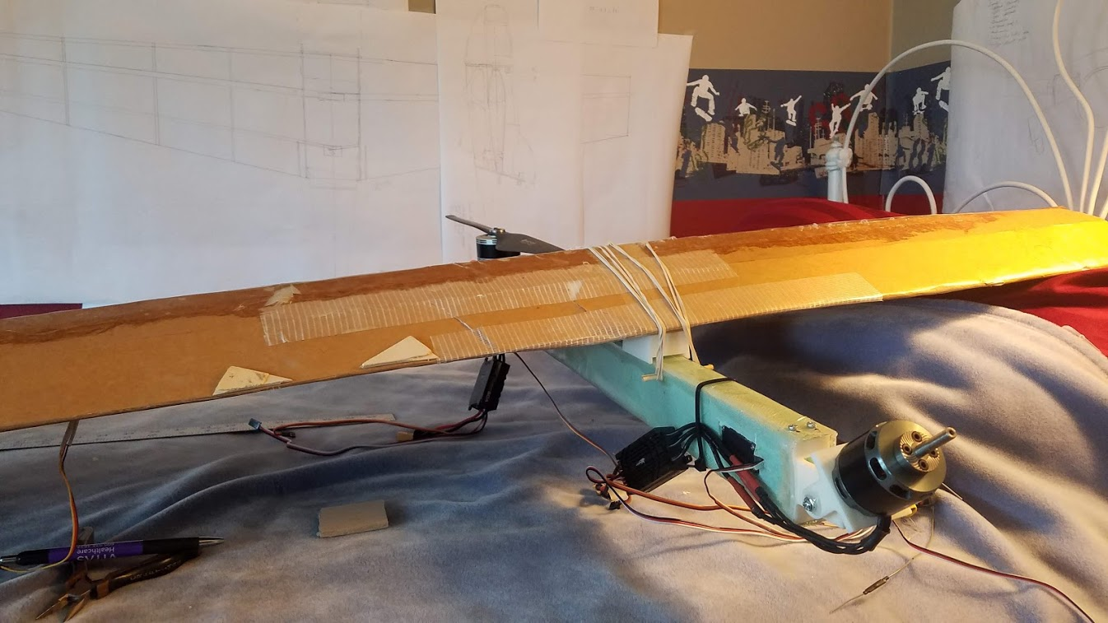
This was a test install done on April 15. As mentioned, it may be a challenge to transfer thrust to the wing during forward flight. I have some ideas on addressing this.

April 13, 2020
So today I hooked up the pixhawk in Muse to my computer and did a number of things. Firstly, I wanted to make sure that most of the systems were still working. I took the aircraft outside and got a good GPS fix. Then, for funsies, I spun up two of the motors.

August test data:
Taking the aircraft back inside, I wanted to see if I could pull down the flight log data from the flights we did back in August. I did it successfully, and after a lot of digging, I put together these estimates from the short flight:

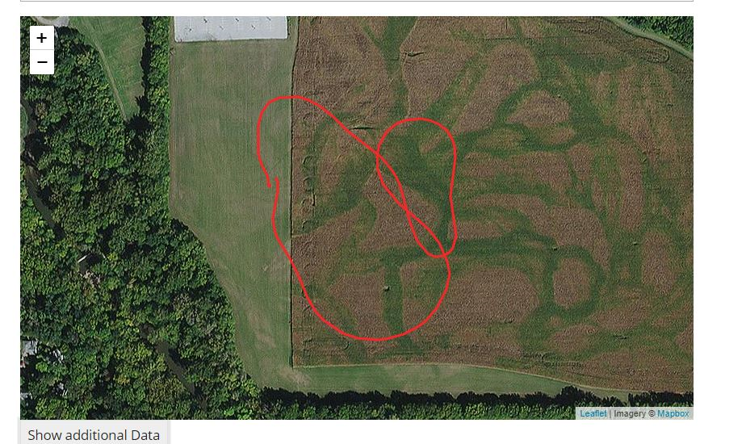
2d-map of our horizontal flight

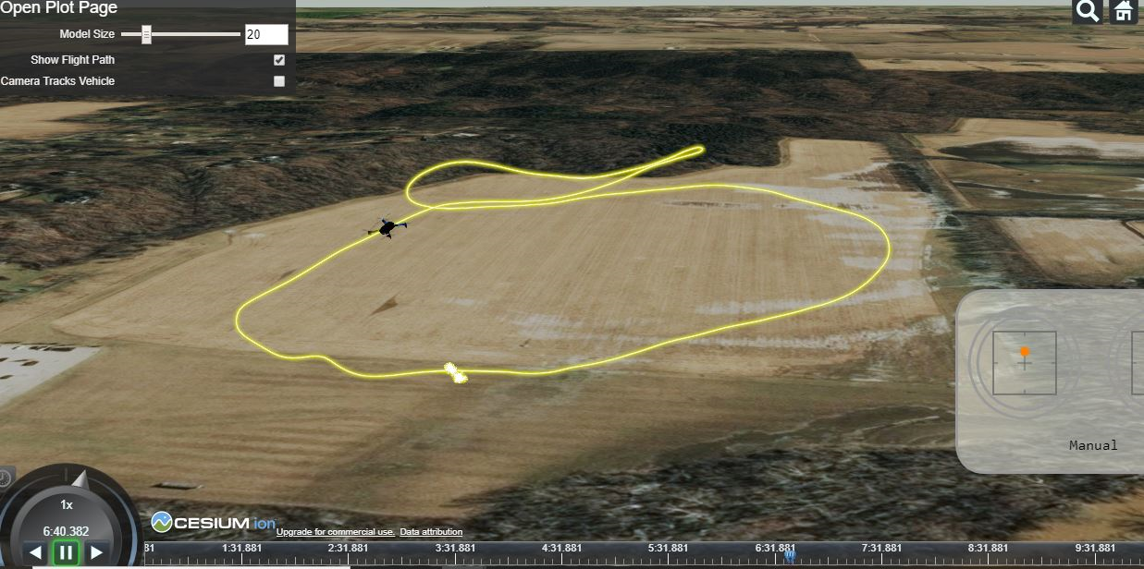
3d-map of our horizontal flight. Where the model is shown is about where the aircraft hit max speed.

Groundspeed while Turning onto final: ~14.5 m/s
Groundspeed while Flaring: 11.5 m/s
Groundspeed at liftoff: ~9.8 m/s (maybe this could be improved by shifting the landing gear forward slightly)
Max Groundspeed Reached: ~137.3 km/h (85 mph). This is not the max speed of the aircraft. The aircraft accelerated to this speed during its climbout before I decreased the throttle.
Max Altitude: 64 m
Cruise input throttle setting was roughly in the 50% range, but it's hard to say. Never really reached a constant cruise nor played with the trim setting. This could definitely be refined with a number of subtle aerodynamic (and other) modifications.

Hover Throttle input (this is my control stick position): ~68-70%

Looking at the data, tt seems that the front motors were "working harder" than the aft motors to lift the vehicle into the air. This doesn't surprise me, but should ideally be addressed in the positioning of the motors.

As predicted, when the front left motor broke off, it had very quickly revved up to full throttle. The left aft motor did rev up, but not quite so high. It's not clear to me why the front motor seemed to react more dramatically.

Regardless, I will certainly make a point of re-calibrating all the ESC's just to make sure they're performing correctly. This is likely especially important now that I am using a new transmitter.

While I was at it, I also re-familiarized myself with the mission-planning interface. During last year’s project, Gabe handled this most of the time, so I refamiliarizing with it was definitely going to be important. It seemed straightforward, and I put together a hypothetical mission to:
- Takeoff vertically in my back yard
- Transition to horizontal flight
- Transition to a hover over my field
- Hover for a short distance
- Transition back to forward flight
- Fly home
- Transition back to a hover and land vertically
This is obviously not going to happen any time soon, but it’s good to prepare.

